PRESS RELEASE 28th August 2007

Off-Licences call for mandatory staff training

The National Off-Licence Association, representing 330 independent off-licences throughout the country, has called for the introduction of mandatory training for all managers and staff working in off-licensed outlets. Speaking at their annual Irish Wine Show (today 28th August), Jim McCabe, Chairman of the Association said that with the liberalisation of licensing and the resultant availability of alcohol in an increasing number of retail outlets the prospect of increasing alcohol abuse will escalate even further if staff in those businesses are not properly trained.

“Selling alcohol is a very serious business and carries special responsibilities. With alcohol now much more widely available, as a result of relaxation of licensing by the last government, there is a significant risk that staff in non-specialist outlets will not be fully aware of their responsibilities. This is especially relevant in regard to staff in certain types of outlet, particularly those treating alcohol as merely one of a wide number of product categories with which they are involved in selling or serving. These include large multiples, convenience stores, petrol stations and certain types of catering outlets”, said Mr McCabe.

“All staff engaged in selling or serving alcohol must have a precise knowledge of the liquor licensing laws and must be capable of dealing with situations where customers must be refused service, either on grounds of age, suspected secondary purchasing, intoxication or potential anti-social behaviour. In order to be competent in these areas and also in understanding the need to regard alcohol as a product which must be treated both by retailers and consumers with respect and responsibility, mandatory training is required.

“In many instances management of some types of licensed outlets regard their responsibilities to have been satisfied by simply handing employees some basic written guidelines on alcohol related problems and the law. This is inadequate in a market where the problem of alcohol abuse is repeatedly highlighted.

“The ‘Responsible Trading in the Community’ – RTC – training programme which all members of the National Off-Licence Association must undertake as a requirement for membership, has been acknowledged both in Ireland and internationally as the most positive proactive initiative to promote responsible retailing of alcohol. As such it is a ready-made blueprint for a nation-wide training project.

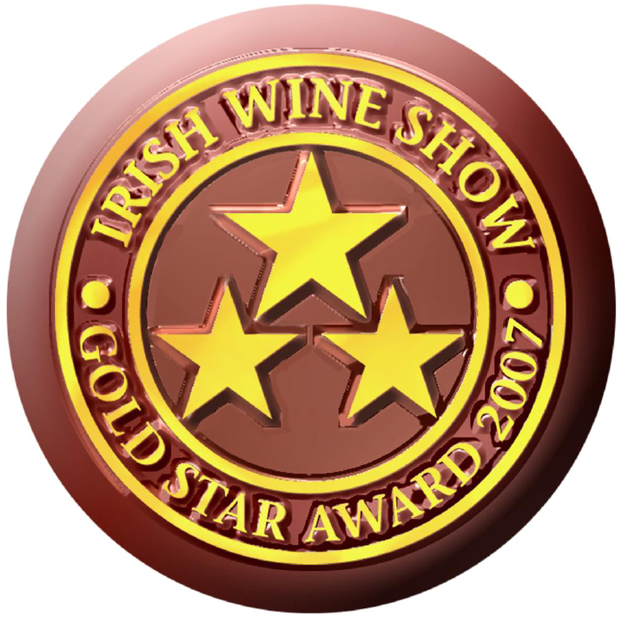

“If a national training programme is to be undertaken it should preferably be under the auspices of a fully independent training and accreditation authority and the National Off-Licence Association would welcome the establishment of such a body and would support it. We would also be prepared to make our considerable expertise as specialist retailers available to it”, said Jim McCabe.

Mr McCabe was speaking at the opening of the seventh Irish Wine Show, a trade-only event attended by all the major national and international wine distributors and suppliers.

A feature of the Show was the announcement of the winners of the prestigious Gold Star Awards, presented to a selection of 15 wines in a range of categories, priced at under €8, under €14 and under €20 at retail level. This selection of wines was chosen by a panel of qualified wine experts and will be exclusively marketed in the 330 member outlets of the National Off-Licence Association nationwide.

The Irish wine market is the most buoyant sector of the Irish drinks business, having increased in sales by 70% since the year 2000. Annual sales of wine in Ireland have now reached 8.2 million cases. Off-licensed outlets account for more than two-thirds of wine sales. “With intense competition in the sector, the Irish wine drinker is not only enjoying very competitive prices, but also a very extensive product choice, with the typical specialist off-licence stocking up to 500 varieties of wine,” stated Jim McCabe.

ENDS
For further information contact:

Richard Barry (087 8141212) Cathal McHugh ( 086 8121667)

